CS 328: Assignment 1 Part 2

**Group Assignment**

**Deadlines**:

Demo deadline: March 10 in class (attendance and demo required)

Code submission deadline: March 10

Code submission deadline: 11:59 PM (this is when Github Classroom will stop accepting submissions. The extra time after the demo deadline is provided for you to incorporate any feedback you get during the in-class demo, clean up your code if required, and commit and push to Github. Your code will be inspected later to check your implementation).

No late submissions will be accepted.

**Assignment Instructions:**

* This assignment contains one Jupyter notebook, “PPG-Assignment.ipynb”, that you are required to complete and submit. You will be estimating heart rate and breathing rate from a given PPG signal after filtering it appropriately.
* You can import any methods you choose from scipy.signal, but other additional imports are not allowed.
* Sample graphs of filtered signals are given below to help you tune your filter parameters. Note that these are just guidelines and your graphs may not turn out to be exactly similar.

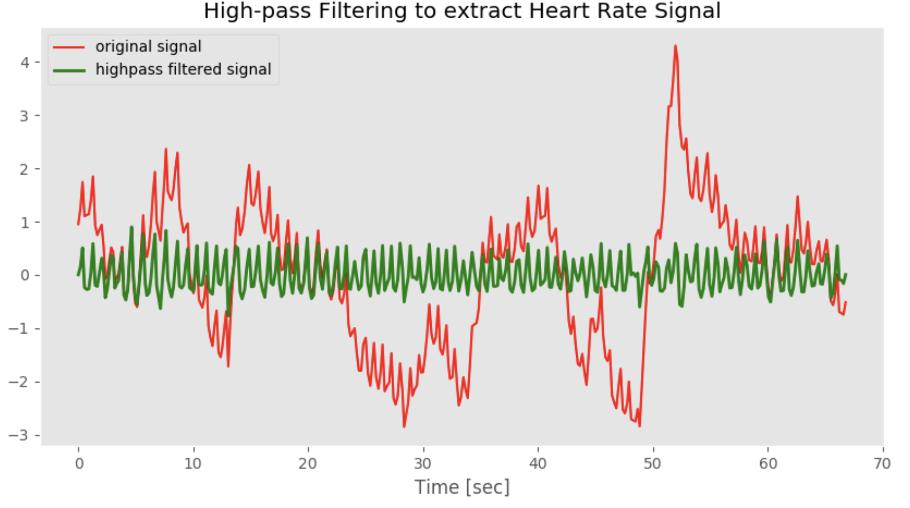

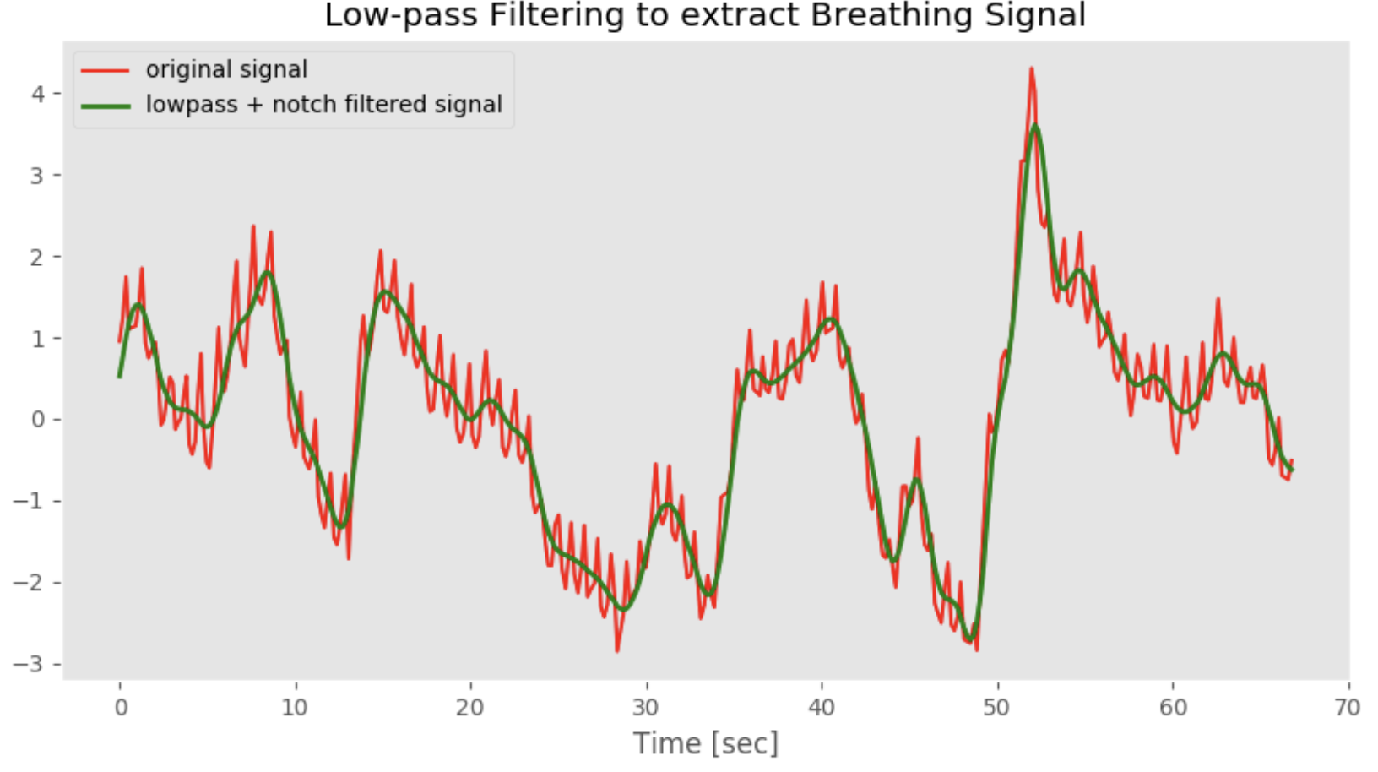

* More instructions are contained in the Jupyter notebook in the places where you are required to fill in the code.
* Commit and push your changes periodically. The TA/graders will only grade your last commitment before the deadline.